Instruction Manual
for RSK-MBSW1 Remote Actuators
used on GE Magne Blast Raise/Lower
Toggle Switch

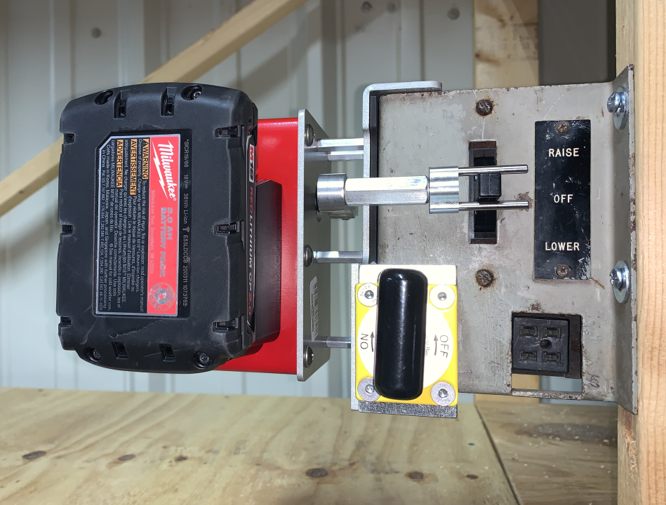

Models:
RSK-MBSW1-30C
RSK-MBSW1-50C
RSK-MBSW1-W

(intentionally left blank)

Table of Contents
1.0 Introduction…………………………………………....…………………………. 1

- General Safety Information…………………………………………………….. 1
  - Arc-Blast Hazards……………………………………………………… 1
  - Battery Hazards…………………………………………………….….. 2
  - Magnet Hazards……………………………………………………….. 2
  - Pinch Point Hazards…………………………………………………… 3
2.5 Radio Frequency………………………………………………..……… 3
3.0 Battery & Charger Information ……………………………………………….... 4
3.1 Installing and Removing the Battery on the CSxxW Actuator...….. 4
3.2 Replacing the Battery in the Wireless Remote Controller …….…... 5
3.3 Charging the M18 Battery ………………………………….………… 5
4.0 Use and Operation of the MBSW1.………………………...…………………... 5

5.0 Storage ………………………………..…………………………………………. 9

6.0 Troubleshooting …………………………..…………………………………….. 10
7.0 Specifications ……………………………………..…………………………….. 11

8.0 Warranty……. …………………………………………………………………… 12

9.0 Contacting the Manufacturer …………………………………………...……… 12

ATTACHMENTS

Milwaukee Operator’s Manual M12/M18 Multi Voltage Chargers
Milwaukee Instructions for Lithium-Ion Battery Packs

Use and Operation Instructions

MBSW1 Remote Actuator for Operating the Raise/Lower Toggle-style Switch on GE Magne Blast Breakers

1.0 Introduction
The MBSW1 models are designed to remotely operate the Raise/Lower Toggle-style Switch on GE Magne Blast Breakers.

.

Model: RSK-MBSW1-30C | Model: RSK-MBSW1-50C | Model: RSK-MBSW1-W
MBSW1 Cabled Actuator | MBSW1 Cabled Actuator | MBSW1 Wireless Actuator
RTL-3 Hand-held transmitter  Milwaukee M18-CP2.0 battery  Milwaukee M18 battery charger  30-foot cable  Instruction Manual  Pelican Carrying Case | RTL-1 Hand-held controller  Milwaukee M18-CP2.0 battery  Milwaukee M18 battery charger  50-foot cable  Instruction Manual  Pelican Carrying Case | RTL-1 Hand-held controller  Milwaukee M18-CP2.0 battery  Milwaukee M18 battery charger  Instruction Manual  Pelican Carrying Case

2.0 General Safety Information:
HAZARD OF ELECTRIC SHOCK, EXPLOSION, OR ARC FLASH
• This equipment must only be installed by qualified personnel.
• Only use this equipment after reading and understanding all of the instructions contained in this manual.
• Follow electrical safe work practices. See NFPA 70E or CSA Z462
FAILURE TO FOLLOW THESE INSTRUCTIONS COULD RESULT IN DEATH OR SERIOUS INJURY

2.1 Arc-blast Hazards

The hazards associated with electrical arc-blasts are well documented. Studies conducted by numerous industries and professional organizations have sought to quantify the intensity of arc blast, the risks to personnel, and various methodologies for mitigating the risks.

Without a doubt, increasing the distance between the arc and a human is the single greatest favorable factor in reducing injuries. Remote operation of electrical equipment is not a cure-all, but rather one more tool available for protecting workers while they are performing electrical switching. Using the MBSW1 remote operating device may not negate the need for additional personal protective measures. The user is ultimately responsible for evaluating each situation to determine if additional protective measures are needed.

2.2 Battery Hazards
THIS EQUIPMENT CONTAINS LITHIUM-ION and ALKALINE CONTAINING BATTERIES
- All Federal and State regulations must be followed for disposal, transport, and shipment of the batteries and equipment.
- Rechargeable batteries should only be charged using chargers approved for the battery type and manufacturer.

The MBSW1 is battery powered from a Milwaukee Tool M18 battery. The voltage output on the battery is 18VDC. Although this is below the recognized threshold for a shock hazard, there can be significant energy stored in the battery pack. See Section 3.0 for more information on the M18 battery.

The M18 Milwaukee battery contains Lithium-Ion cells. Care must be taken when handling the battery and federal regulations must be followed when shipping the battery.

2.3 Magnet Hazards
THIS EQUIPMENT UTILIZES POWERFUL MAGNETS TO HOLD IT ON THE SWITCHGEAR
Care must be taken to prevent injury when handling this equipment

The magnet that is used on the MBSW1 to hold it on the switchgear produces strong magnetic fields, so care must be taken when handling it. The following steps should be followed to assure safe handling:
- The magnet should always be kept in the OFF position when not in use and should be kept at a safe distance from all magnetic storage devices, electronics, credit cards, etc.
- Do not use the MBSW1 if the magnet has been damaged.
- Always keep the bottom of the magnet free of debris and rust. If needed, dirt can be removed using the sticky side of a piece of masking tape.

2.4 Pinch Point Hazards
THIS EQUIPMENT HAS MOVING PARTS THAT PRESENT PINCH POINT HAZARDS
Care must be taken to prevent injury when handling the equipment.

The MBSW1 is a motorized device with moving parts that will produce the opportunity for pinch point hazards. In order to prevent a pinch point injury, the following procedures should be followed:
- Install the MBSW1 actuator on the switchgear prior to turning it on.
- Once the MBSW1 is turned ON, do not touch or bring body parts near the actuator.
- Turn OFF the MBSW1 actuator prior to removing it from the switchgear door.
- Do NOT attempt to turn the MBSW1 actuator ON unless it is installed or laying on a table. DO NOT TURN IT ON AND THEN HANDLE IT WITH IT ON.

Additionally, the magnet used to hold the MBSW1 actuator on the switchgear door could present a pinch hazard. To prevent an injury the follow procedures should be followed:
- Keep all fingers away from the magnet areas when installing.
- Follow the installation procedure in Section 4.0 when installing the MBSW1 on the switchgear door.

2.5 Radio Frequency

The wireless version of the MBSW1 uses a radio transmitter and receiver to communicate. The transmitter and receiver operate in the 2.4GHz frequency band and is low power at 6.3mW. These are commercially available radios that have agency certification through the manufacturer. They are certified with the following agency approvals:

United States – FCC
FCC ID: MQC-XBEE3
The enclosed device complies with Part 15 of the FCC Rules. Operation is subject to the following two conditions: (i.) this device may not cause harmful interference and (ii.) this device must accept any interference received, including interference that may cause undesired operation.

Canada – IC
IC: 1846AXBEE3

CAUTION! To satisfy FCC RF exposure requirements for mobile transmitting devices, a separation distance of 20 cm or more should be maintained between the antenna of this device and persons during device operation. To ensure compliance, operations at closer than this distance are not recommended. The antenna used for this transmitter must not be co-located in conjunction with any other antenna or transmitter.

3.0 Battery and Charger Information

THIS EQUIPMENT USES A LITHIUM ION BATTERY PACK.
DO NOT attempt to modify the battery pack or to install a battery pack not approved for use in the MBSW1. Doing so could cause equipment damage, fire, or personal injury.

MBSW1 Actuator Battery

The MBSW1 is powered from a Milwaukee Tool M18 battery. M18 batteries are available in a variety of sizes and capacities. The kit ships with the M18-CP2.0 battery along with a charger, but the user may use any M18 Milwaukee battery. DO NOT ATTEMPT TO USE BATTERIES OTHER THAN THE M18 MANUFACTURED BY MILWAUKEE TOOL. DOING SO WILL VOID THE WARRANTY.

For more detailed user information for the M18 battery, see the Milwaukee Tool Safety Instructions for Lithium-Ion Battery Packs, which is included with this manual. Additionally, SDS sheets are available for the battery through the Milwaukee Tool website.

See Section 3.3 for information on charging the M18 battery.

Shipping of Lithium-Ion Batteries

The M18 battery cannot be shipped via air if properly packaged. Contact your shipper directly for the lastest requirements.

RTL-3 Remote Transmitter
The RTL-3 is a remote transmitter used with the wireless version of the MBSW1. It is powered by a 9VDC battery. Replace this battery as needed with a commercially available 9VDC battery. An alkaline or non-rechargeable lithium type is recommended.

3.1 Installing and Removing the Battery on the MBSW1 Actuator

Installing and removing the battery on the MBSW1 is easily performed by sliding the Milwaukee M18 battery into or out of the adapter on the side of the MBSW1. The battery locks into place when properly installed and can be removed by simultaneously squeezing the red colored release buttons on both sides of the battery.

3.2 Replacing the Battery in Wireless Remote Transmitter

The RTL-3 remote transmitter uses a standard 9V battery.

To replace the battery, complete the following steps:
- Remove the battery cover on the back of the transmitter.
- Replace the battery.
- Re-install the battery cover.

3.3 Charging the M18 Battery

The M18 battery must only be charged using a charger approved by Milwaukee Tool. Included with the MBSW1 is an approved Milwaukee Tool charger. The standard part number provided is 48-59-1812, however, some kits may ship with a different charger depending on the input voltage required. For more detailed user information for the M18 chargers, see the Milwaukee Tool Operator’s Manual for Multi-Voltage Chargers, which is included with this manual.

4.0 Use and Operation of the MBSW1

The MBSW1 is installed on the Raise/Lower Toggle-style switch assembly found on most GE Magne Blast breakers with built in racking motors. Care must be taken when installing the MBSW1 that the Raise/Lower switch is not inadvertently operated.

The MBSW1 should be installed by first prepositioning the actuator arm to the current position of the Raise/Lower Switch.

Looking at the toggle switch on the switchgear, determine if the actuator fork is in the right position to align with the toggle switch on the switchgear. If it is not in aligned properly, use the following steps to properly position the actuator fork.
  - Lay the MBSW1 actuator on a clean surface
  - Install the Milwaukee Battery
  - Press the WAKE button
  - Keeping fingers and body parts away from the actuator, use the hand-held controller to advance the fork arm up or down as necessary to get the fork arm in the correct position.
- Hold the ENABLE and momentarily and press either the RED or GREEN button to move the fork in the desired direction. Each press of the button will advance the fork one position.

The switchgear door must be clean and free of obstacles such as labels that may prevent the magnet from fully engaging the toggle switch mounting plate. IF THE MAGNET DOES NOT FULLY CONTACT THE METAL OF THE PLATE, THE ACTUATOR MAY FALL OFF DURING OPERATION.

STEP #1 – Verify that the magnet is in the OFF position.

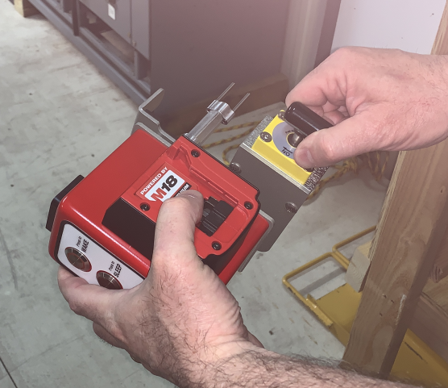

STEP #2 - Holding the MBSW1 as shown, slide the actuator to the right while, at the same time, engaging the fork on the toggle switch as shown below.

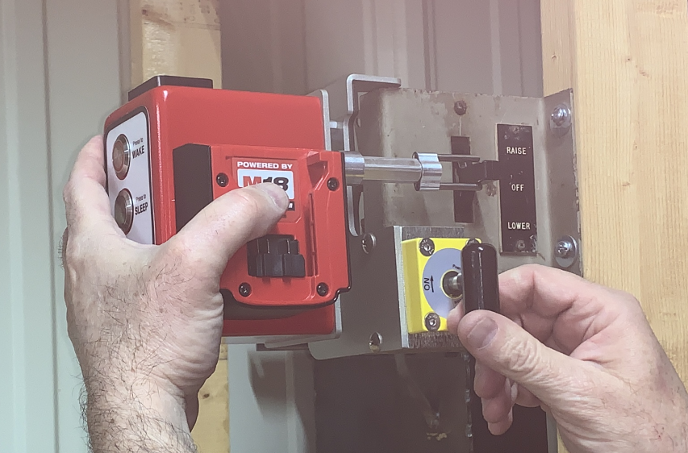
Keep top of frame aligned with top of toggle switch plate.
Fork engages toggle switch.

STEP #3 – While holding the actuator firmly in place with the top of the frame against the top of the toggle switch plate, turn the magnet ON.

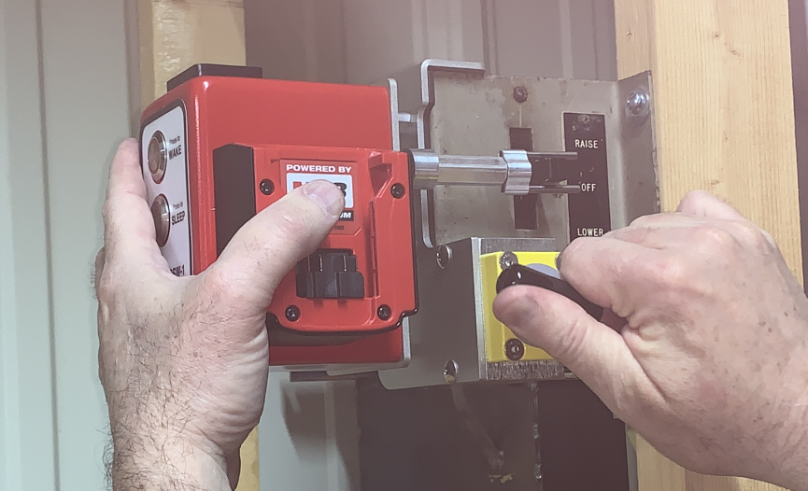
Keep top of frame against top of toggle switch plate and the actuator all the way to the right and against the toggle switch plate.

STEP #4 – Install the Milwaukee battery.

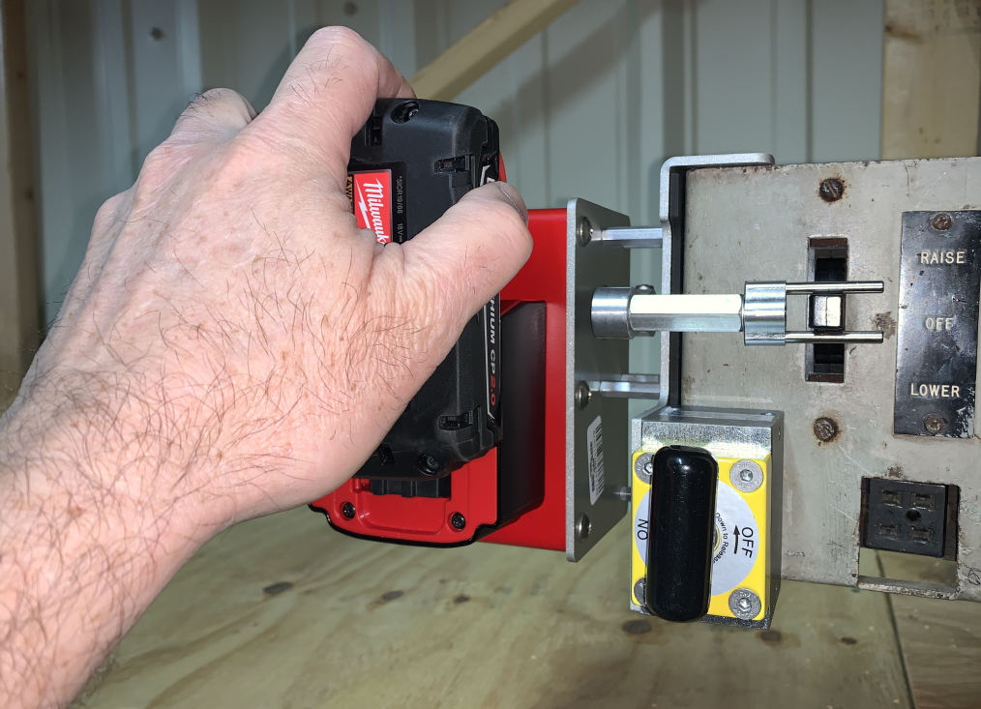

STEP #5 – Press the WAKE button to power up the unit. The WAKE button should light indicate that power is on.

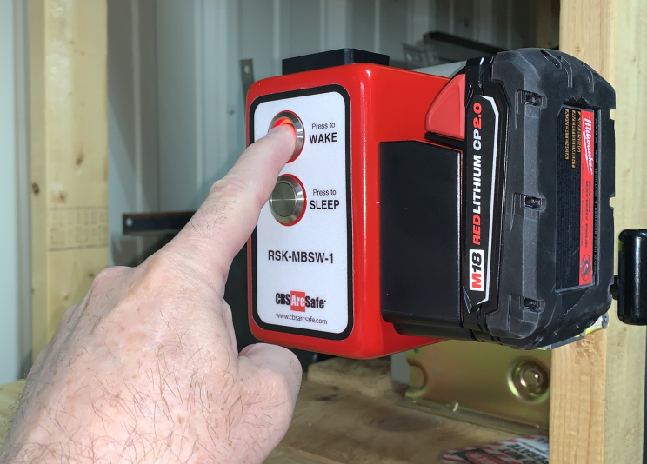

STEP #6 – While standing at a safe distance, press and hold the ENABLE button on the hand-held controller and then momentarily press the RED or GREEN button to cause the actuator to move the toggle switch either UP or DOWN one position. Repeat this step if toggle switch needs to be moved one additional position, or in opposite direction.

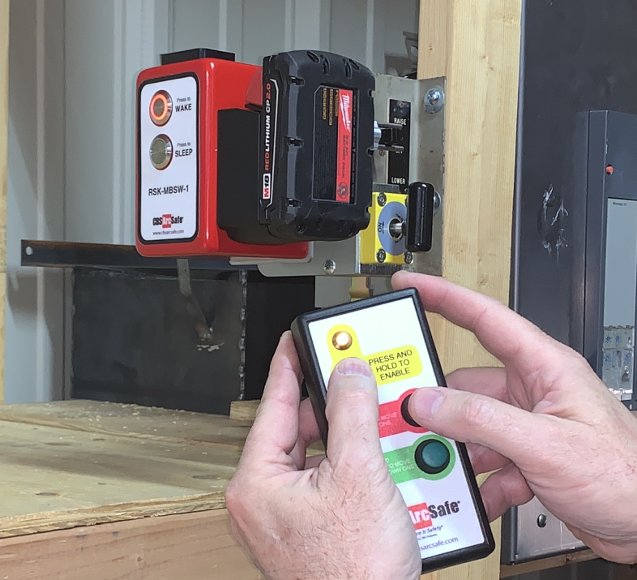

STEP #7 – Once switching is completed, remove the actuator in the reverse order of installation. Press SLEEP button, remove battery, and then remove actuator. BE SURE TO TURN MAGNET OFF TO REMOVE. ATTEMPTING TO PULL THE ACTUATOR STRAIGHT OFF THE DOOR IS DIFFICULT AND COULD CAUSE INJURY OR ACCIDENTAL OPERATION OF THE PISTOL GRIP SWITCH.

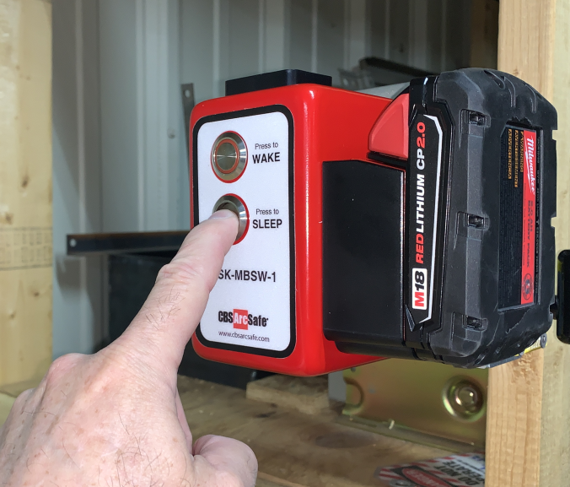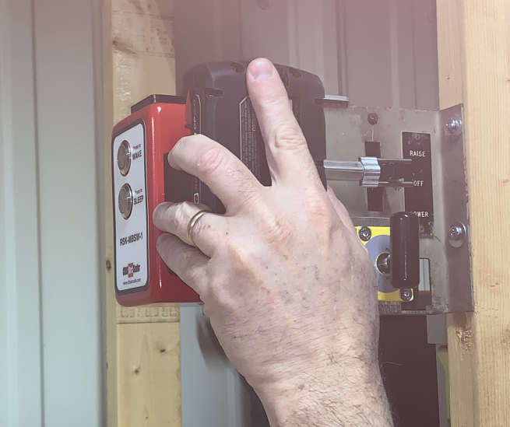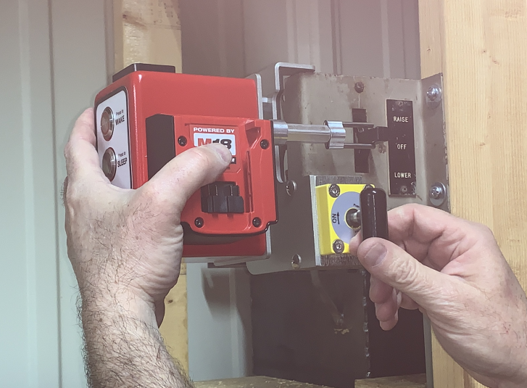

5.0 Storage

The RSK-MBSW1 is provided with a heavy-duty carrying case that can be used to conveniently store the actuator and its necessary components. The carrying case and complete unit should be stored in a clean and cool environment.

6.0 Troubleshooting

SYMPTOM | SOLUTION
The LED on the Wake button flashes and then the unit shuts down. | If the MBSW1 actuator is not operated within 1 hour after powering on, it will automatically shutdown. Press the WAKE button to turn it back on
The RTL-3 wireless transmitter won’t activate the MBSW1 or the actuator operates sporadically. | 1) the transmitter is outside the 100-foot range or if there are obstructions limiting the ability to reach 100-feet.  2) the battery voltage could be low in the RTL-3. Try replacing the battery.

7.0 Specifications

Actuator and Hand-held Controller Voltage | MBSW1 – 18 VDC  RTL3 – 9VDC
M18 Battery and Charger  by Milwaukee Tool | M18 CP2.0 (Milwaukee part number 48-11-1820) recommended  Other M18 batteries are also compatible. DO NOT USE BATTERIES NOT MANUFACTURED BY MILWAUKEE TOOLS. DOING SO WILL VOID THE WARRANTY.
M18 Battery Charger  By Milwaukee Tool | Most kits ship with Milwaukee Tools part number 48-59-1812, which is rated for 120VAC input. Other similar chargers may be included based on customer needs.
Magnet | 400lbs/181kg magnet strength, 20lbs/9kg sheer load.
Wireless Transmitter | Operating frequency 2.4Ghz, 6.3mW output. 100-ft range line of sight.  Transmitter and actuator are paired so that the transmitter can only operate the actuator that has been paired with it. Pairing is factory programmed and is not user programmable.
Projected Life | 20,000+ operations
Carrying case | Manufactured by Pelican with the following features:  Two Press & Pull Latches  Double-layered, Soft-grip Handle  Two Padlockable Hasps  Vortex® Valve  Flush Powerful Hinges  Lightweight Strong HPX® Resin  Watertight  Meets airline regulations for carry-on luggage  Exterior Dimensions 16.20” x 12.70” x 6.60” (41.1 x 32.2 x 16.8cm)
Weight | MBSW1 Actuator (with M18-CP2.0 battery) – 7.2lbs / 3.3kg  Complete Kit with carrying case – 16lbs / 7.3kg

8.0 Warranty

CBS ArcSafe® guarantees all products manufactured by CBS ArcSafe® only against defects in materials and/or workmanship for a period of twelve (12) months commencing on the date the product is received by the customer. THIS WARRANTY IS IN LIEU OF ALL OTHER EXPRESS OR IMPLIED WARRANTIES INCLUDING THOSE OF MERCHANTABILITY AND FITNESS FOR A PARTICULAR PURPOSE. CBS ArcSafe® will, at its option and its cost (excluding shipping expenses) repair, replace or refund the purchase price of any product manufactured by CBS ArcSafe® which has a covered defect in materials and/or workmanship. THIS IS CUSTOMER’S EXCLUSIVE REMEDY FOR BREACH OF WARRANTY. IN NO EVENT WILL CBS ARCSAFE’S® LIABILITY FOR DAMAGES (WHETHER ARISING FROM BREACH OF CONTRACT OR WARRANTY, NEGLIGENCE, STRICT LIABILITY OR OTHERWISE) EXCEED THE PURCHASE PRICE OF THE PRODUCT CONCERNED NOR WILL CBS ARCSAFE® BE LIABLE FOR PUNITIVE, INCIDENTAL, CONSEQUENTIAL OR SPECIAL DAMAGES (INCLUDING WITHOUT LIMITATION LOST PROFITS) EVEN IF ADVISED OF THE POSSIBILITY OF SUCH DAMAGES. This warranty does not cover damage caused by accident, improper care, negligence, normal wear and tear, natural causes, unlicensed repairs, and incompetent supervision. This warranty also does not cover repairs or replacements made by unauthorized individuals except when agreed to in writing. CBS ArcSafe® reserves the right to disallow warranty repairs if the unit has been disassembled or misused, as determined by CBS ArcSafe® in good faith. Please contact us at (877) 472-3389.

9.0 Contacting the Manufacturer

For any questions, repairs, or parts replacement please contact the manufacturer using any of the methods below.

2616 Sirius Road
Denton, TX 76208
(940) 382-4411
(877) 472-3389
WWW.CBSArcSafe.com

